Password Management System
Majed A. Hariri, Rayan A. Aldhubaib, Dr. Rizdan Mohammed, Mr. Fazal Khan, Dr. Mohammed Fazil
Department of Information Technology, Faculty of Computing and Information Technology, King Abdulaziz University, Jeddah, Saudi Arabia
Emails: majedoh@gmail.com, mr.rayyyan@gmail.com, anriz@hotmail.com, fazalqudus@hotmail.com, fazil@hotmail.com

ABSTRACT
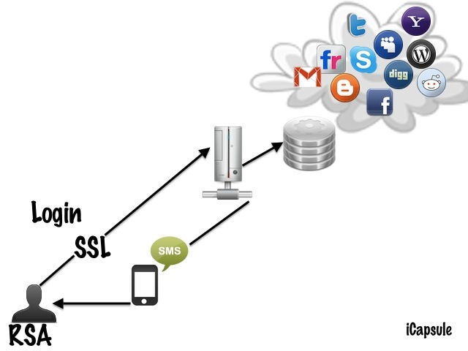
Recent developments in the technical field led to the observed expansion in the provision of services such as many sites provide services requiring passwords protection. So, the beneficiaries of such sites users must remember many passwords when they visit to these web pages/sites. It is highly recommended for the users to select a strong password that includes mixed combination of numbers and letters that should not contain personal information. For security reason, we suggest not to write password on paper or note, where it is easy to be seen by Intruders. Remembering all these passwords and link each one of them to the specific service seems to be hard. A solution we are establishing a system that controls all these passwords and make it easy to use.
We did not find any project similar to ours providing comprehensive solution of the said problem mentioned above. The main weakness, that of existing programs, is unavailability information for users, so they cannot reach to their information from anywhere in case they need it. Some examples of these types of programs are (KeePass program).
What we plan to do in our project is to introduce a system that provides possibilities and characteristics that helps users to protect their information. Our goal has been to preserve users information and privacy and make it easy to store and retrieve whenever the users need them. Therefor, our program will assist users to remember one password instead of multiple passwords.
We will use advance tools that are appropriate to solve these issues that we mentioned, by using different type of technologies such as (Secure Network, Database, Security, Mobile tech., programming) and strong technique in encryption, which is the RSA algorithm.

Figure 1.1

We did the first prototype, which introduces the interface of the system. For the Second Prototype, we connected the interface with the database and created the registration and login action. In third prototype on which we are working, we will include the RSA algorithm for encrypting the information in the system and we will include the SMS codes for login validation.

